**RV UNIVERSITY**

**School of Computer Science and Engineering**

## **Bengaluru – 560 059**



**Paws & CLAWS**

**Name of the Candidate: Rakshitha.M**

**USN: 1RVU22BSC079**

**Semester: V**

**Course: Full Stack Development**

|  |  |
| --- | --- |
| **Marks** | |
| **Maximum** | **Obtained** |
| **25** |  |

**Signature of Faculty in-charge Date: 06.09.2024**

**Contents**

Abstract i

Introduction 1

Existing System 2

Proposed System 3

i. Modules (Minimum 3 Modules,) 4

Software Specification 5

Code Design 6

Conclusion 7

Reference

**Abstract**

This report presents the design and implementation of a web interface for "Paws & Claws Rescue," an animal rescue and pet care platform aimed at providing a comprehensive range of services, including pet boarding, grooming, training, and adoption. The website's primary objective is to deliver a user-friendly and responsive experience, enhancing usability and engagement for both new and returning users. Key features include a pet boarding section with detailed service descriptions, a fixed navigation header with a dropdown menu for easy access to various sections, and a secure login form equipped with validation mechanisms. The login system is designed to ensure secure access and a streamlined registration process for users. The interface is developed using HTML, CSS, and JavaScript, ensuring cross-browser compatibility and responsiveness across devices. This report outlines the proposed features, modular design approach, and technical specifications that contribute to creating an engaging and secure user experience.

**Introduction**

In today’s digital age, managing pet care efficiently has become increasingly important for pet owners. "Paws and Claws" aims to streamline this process by offering a comprehensive web platform designed to support pet parents in managing their pets’ health and well-being. This project focuses on creating a user-friendly interface that simplifies the process of storing health records, accessing information from experienced vets, and fostering a supportive community. The platform features an intuitive navigation menu, a city selection dropdown for locating services, and a responsive sign-up page with validation to ensure a smooth user experience. Developed using HTML, CSS, and JavaScript, the website is designed to offer an optimized and accessible experience across various devices and browsers. This report will detail the design process, technical implementation, and features of the "Paws and Claws" platform, emphasizing how it enhances the convenience and effectiveness of pet care management.

**Existing System**

The current version of the "Paws and Claws" platform provides a streamlined interface for managing pet care. It includes a clear navigation menu and a city selection dropdown to help users easily find relevant services. The platform features a responsive sign-up page with validation and a login form for user authentication, ensuring accessibility and ease of use. However, there are areas for improvement, particularly in terms of compatibility across various devices and browsers, which is still under development. While the core functionalities—such as storing health records, accessing vet information, and fostering a supportive community—are effectively integrated, the system requires enhancements to improve responsiveness and optimize the user experience across different screen sizes and devices.

**Proposed System**

**Modules (Minimum 3 Modules)**

1. Navigation Module: This module includes the fixed header and navigation bar, providing users with consistent access to key sections of the website. The dropdown menus allow users to explore different categories such as "About Us," "Service," “Know More”, and "Contacts," ensuring that all important information is easily accessible.
2. User Registration Module: The login form is a crucial part of this module. It includes fields for entering a username, password, email, and mobile number. The form also incorporates validation scripts to ensure that the passwords match and that other fields are correctly filled out before submission.
3. City Selection Module:

**Software Specification**

* Languages Used: HTML, CSS, JavaScript
* Tools and Libraries: Font Awesome for icons, standard web fonts, and JavaScript validation scripts.
* Compatibility: The design is compatible with modern web browsers, including Google Chrome, Mozilla Firefox, Safari, and Microsoft Edge.
* Design Approach: The webpage design is initially static and does not yet adapt to different screen sizes. Future updates will include a mobile-first approach to ensure full responsiveness and an adaptive interface that adjusts to various screen sizes. The CSS will be restructured to provide a consistent look and feel across different devices once this feature is implemented.

**Code Design**

**Lab 1: Domain – Agricultural Market Place**

**Create a static web-page.**

1. Creating a static webpage template featuring a navigation menu bar with options such as Home, About Us, Products, and Contact Us, without implementing any underlying functionality and also a search tab and a signup button.

**Output:**

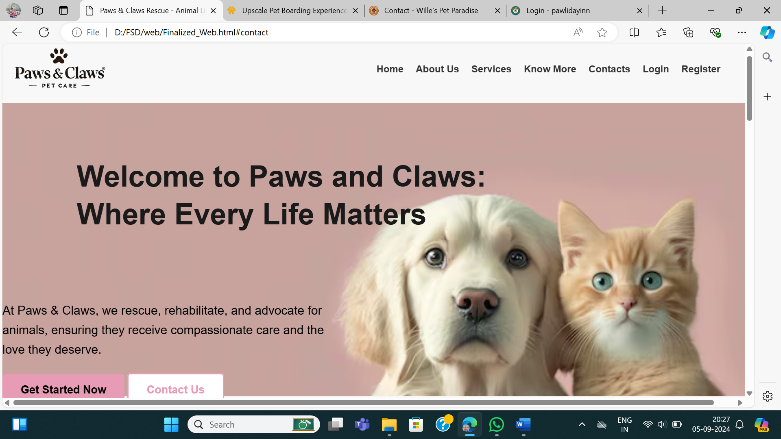

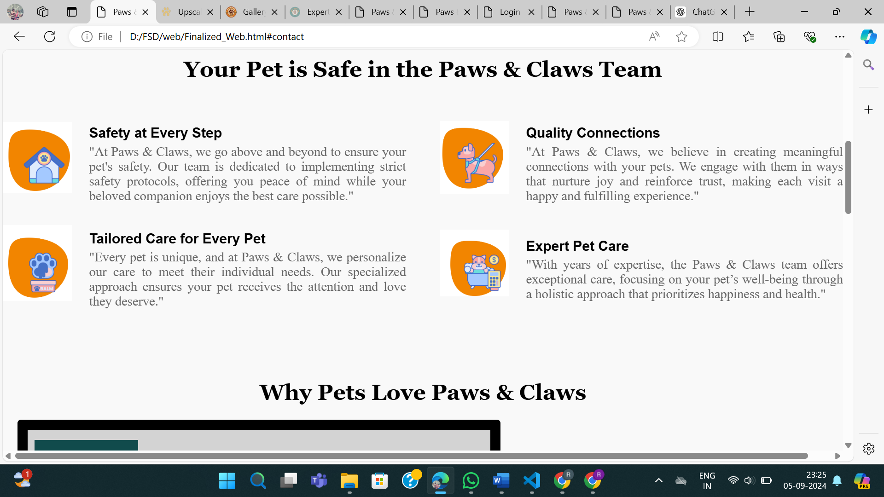

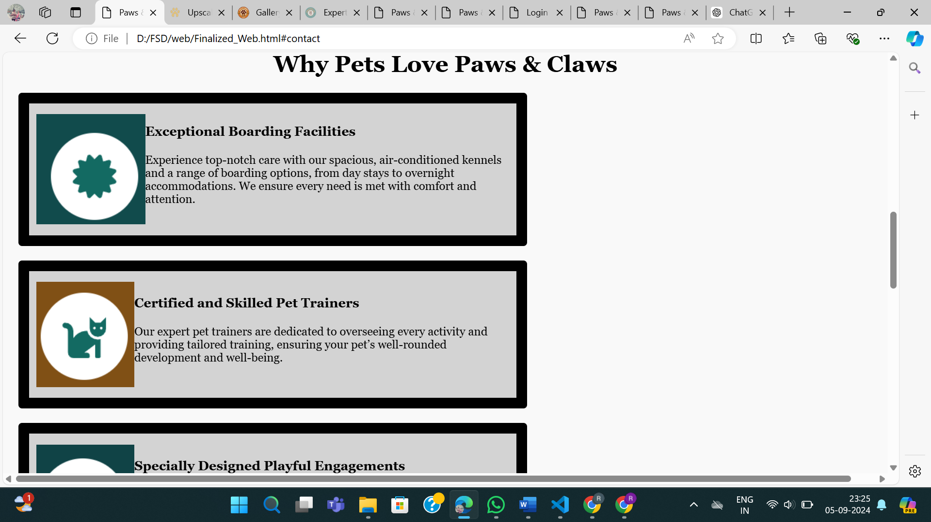

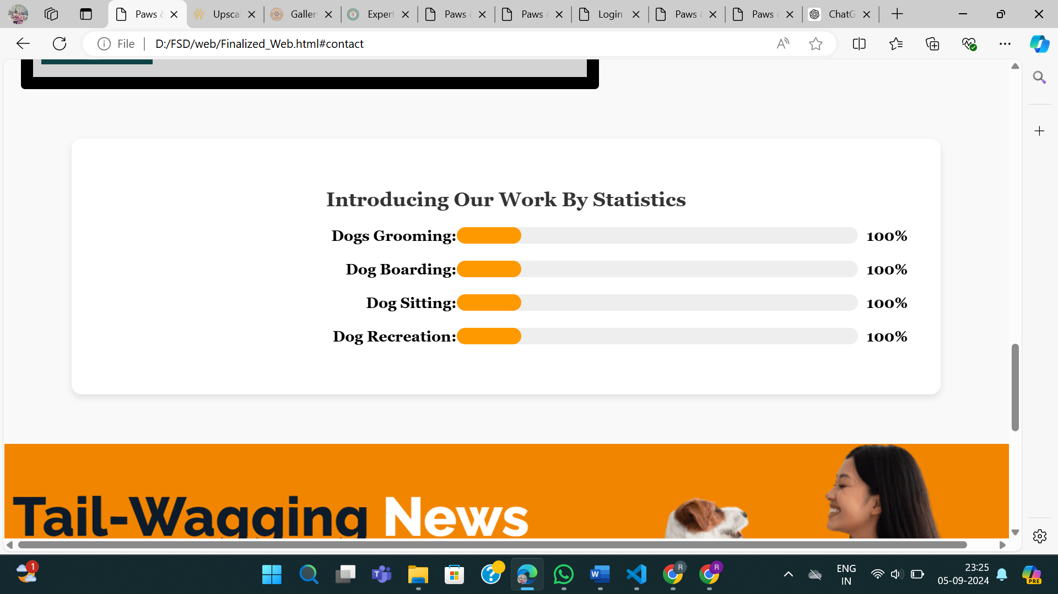

**Coding:**

**HTML** :

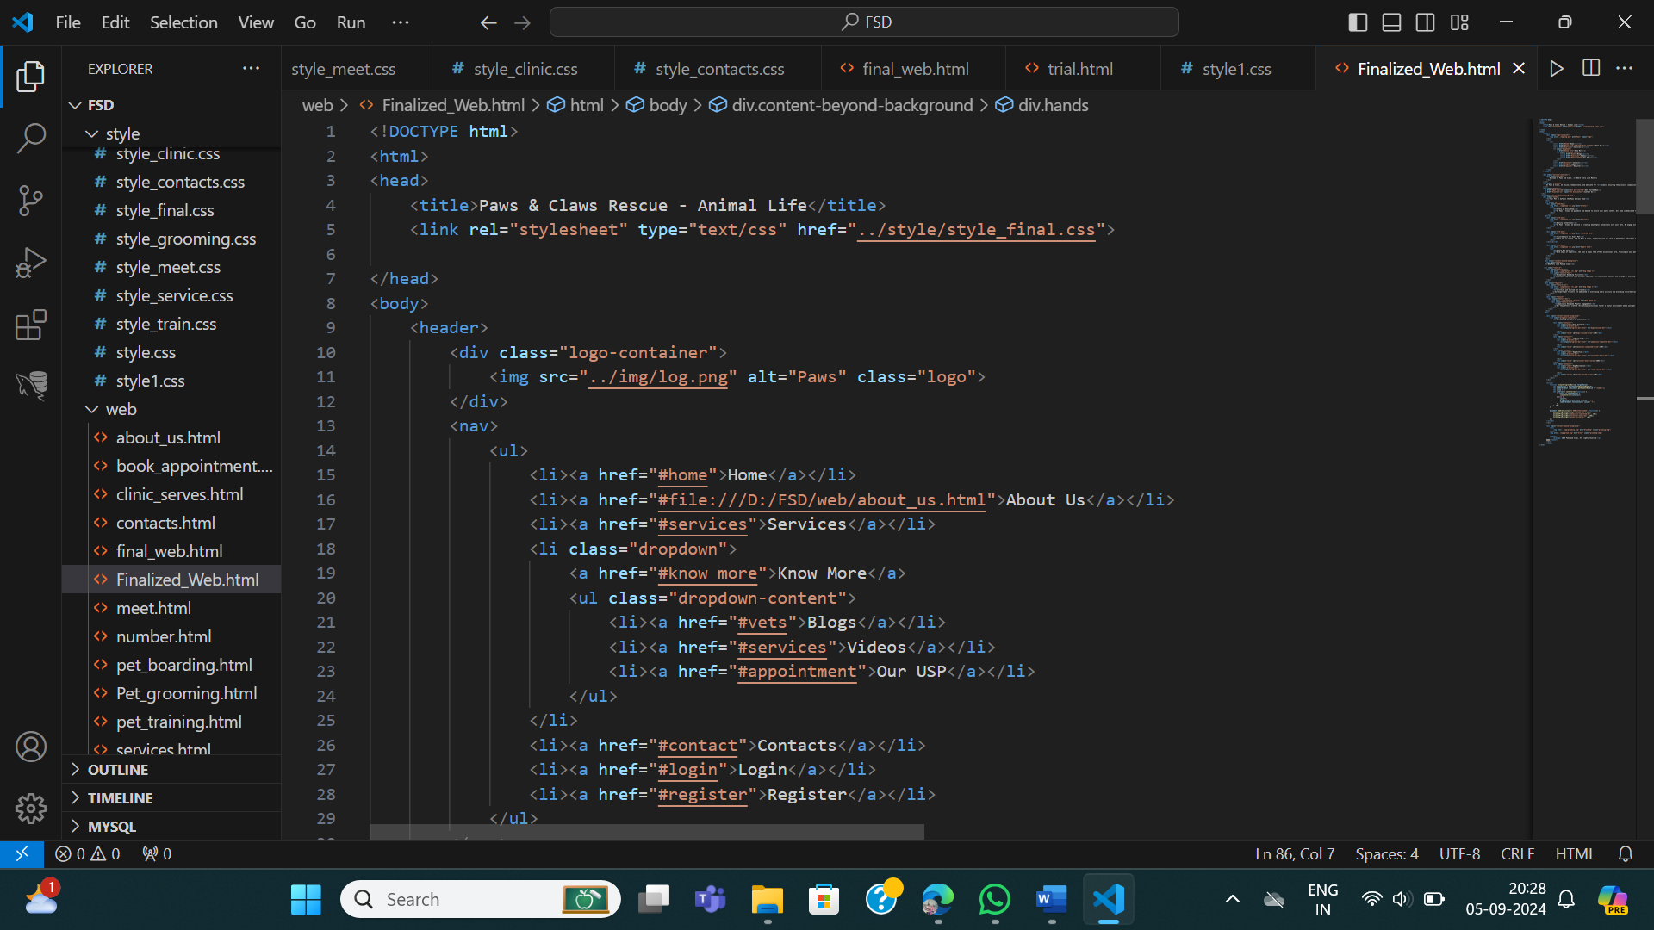

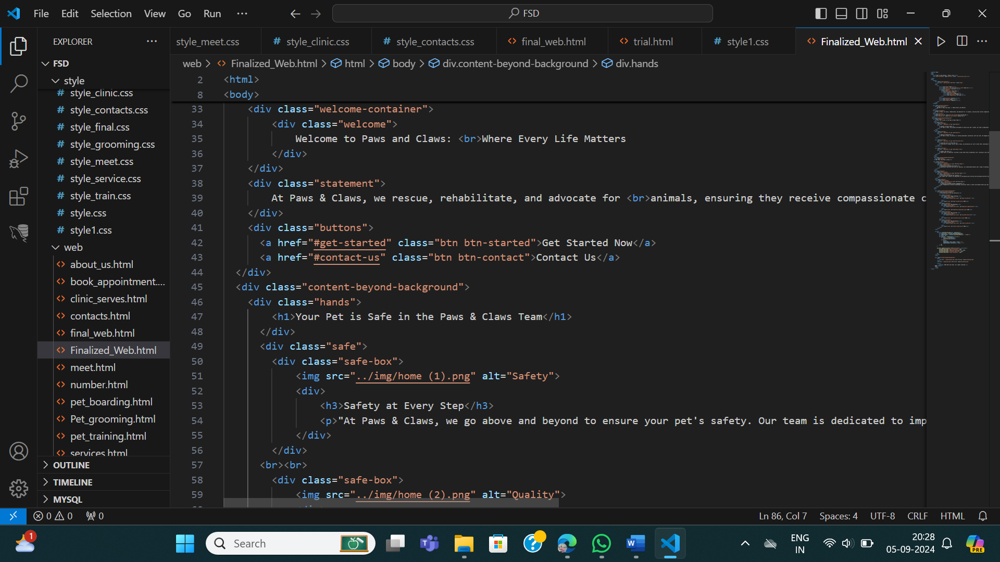

**CSS:** The CSS code includes styling the page, adding a background image, aligning elements, and setting fonts,font- colours etc.

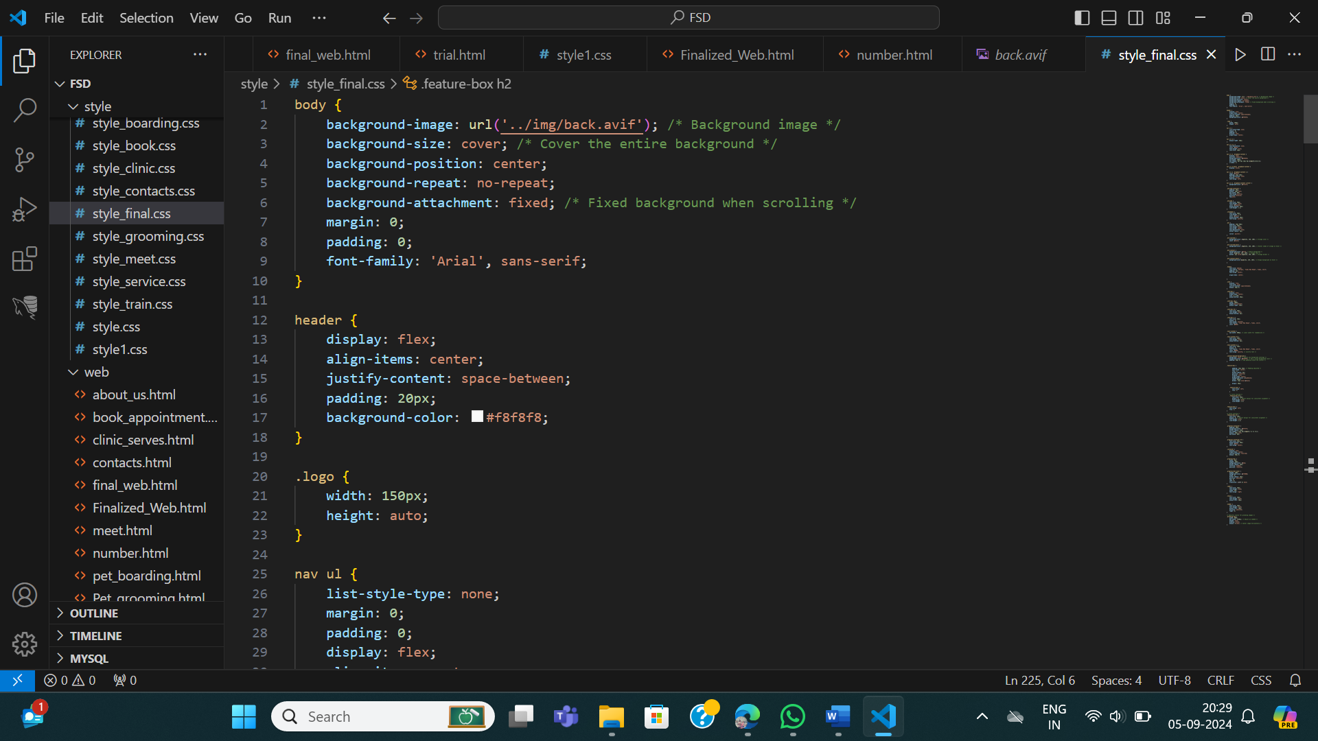

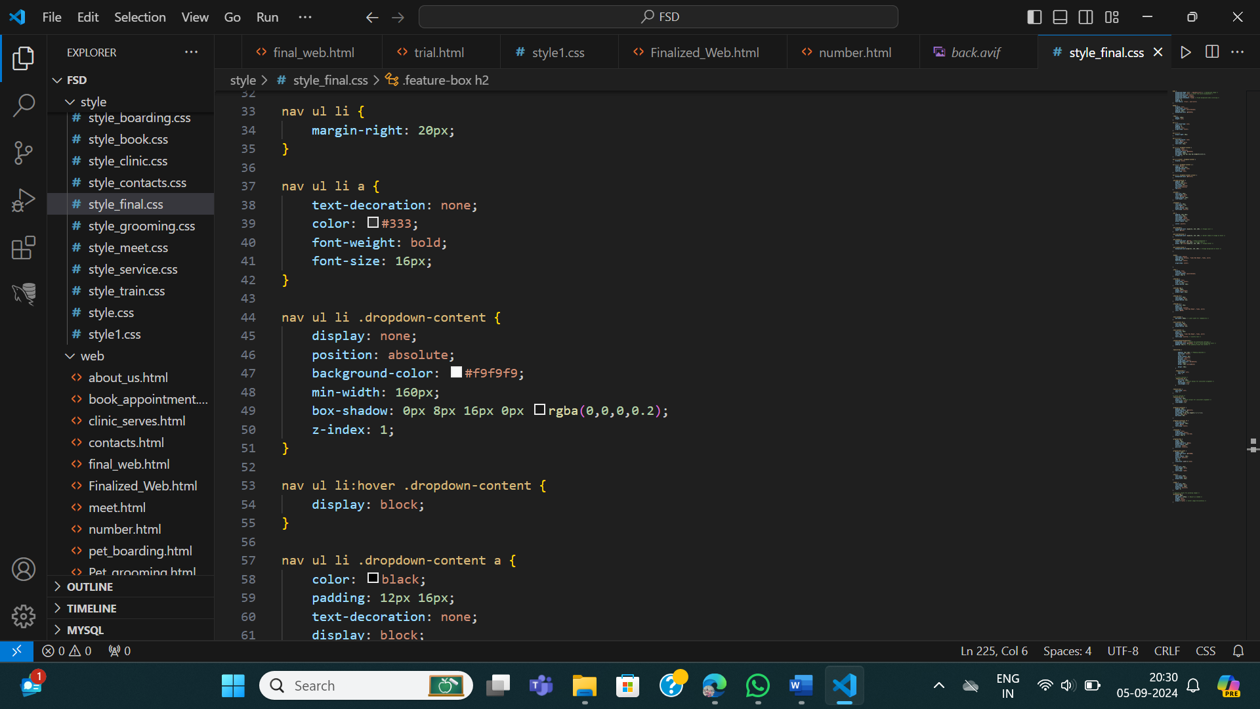

**Lab 1(1): Domain –**

**Design a Login-Up form with validation for following fields.**

1) Creating a Sign-Up page with fields for email, username, password, and repeat password, including validation checks such as displaying an error if the email does not contain '@' and ensuring the password has a minimum of 6 and the age limit must not exceed 100yrs.

**Output:**

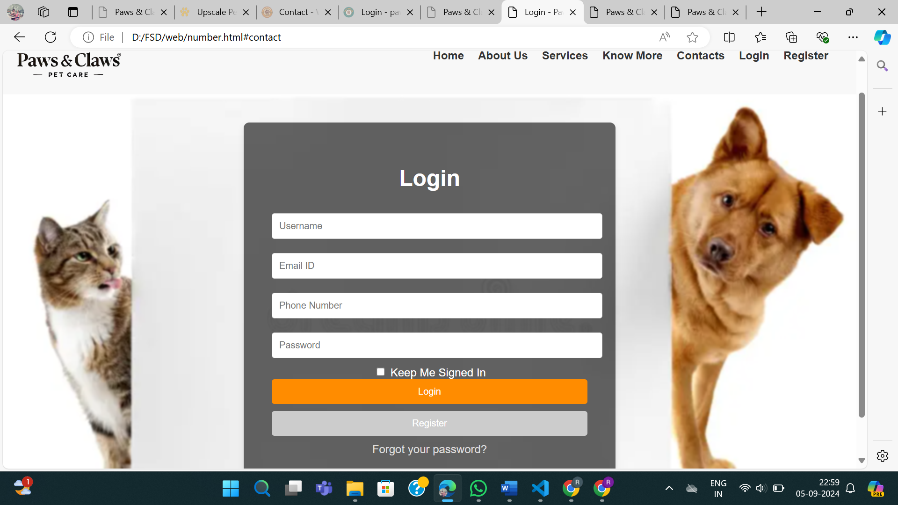

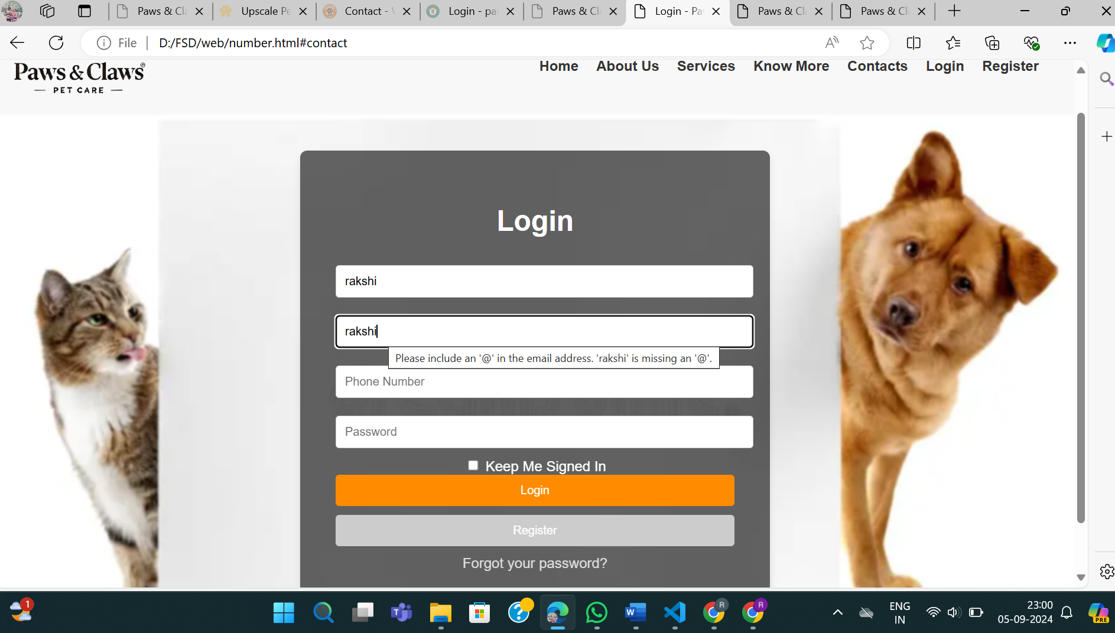

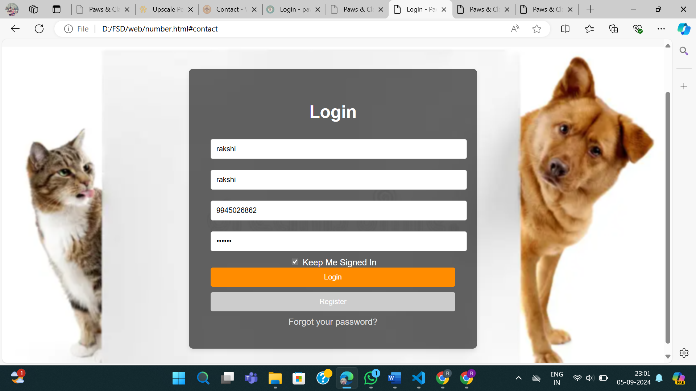

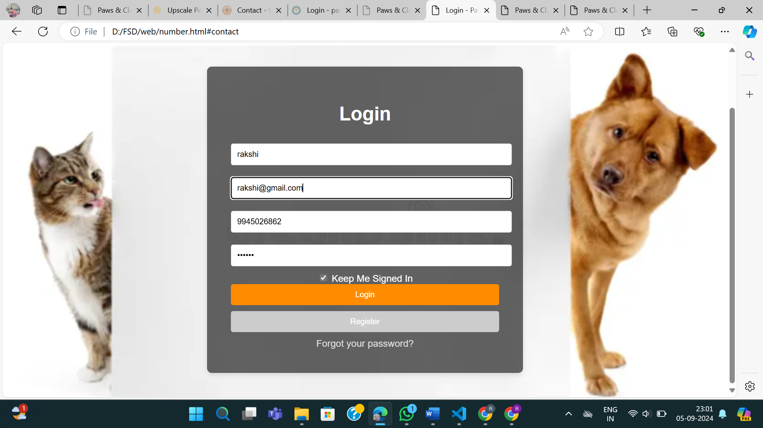

**Coding:**  **HTML , CSS and Java script**

The HTML and CSS is used to create and designing the sign-up page, java script is used to checks if the password and retyped password fields match before submitting the form. If they don't match, it prevents submission of the form.

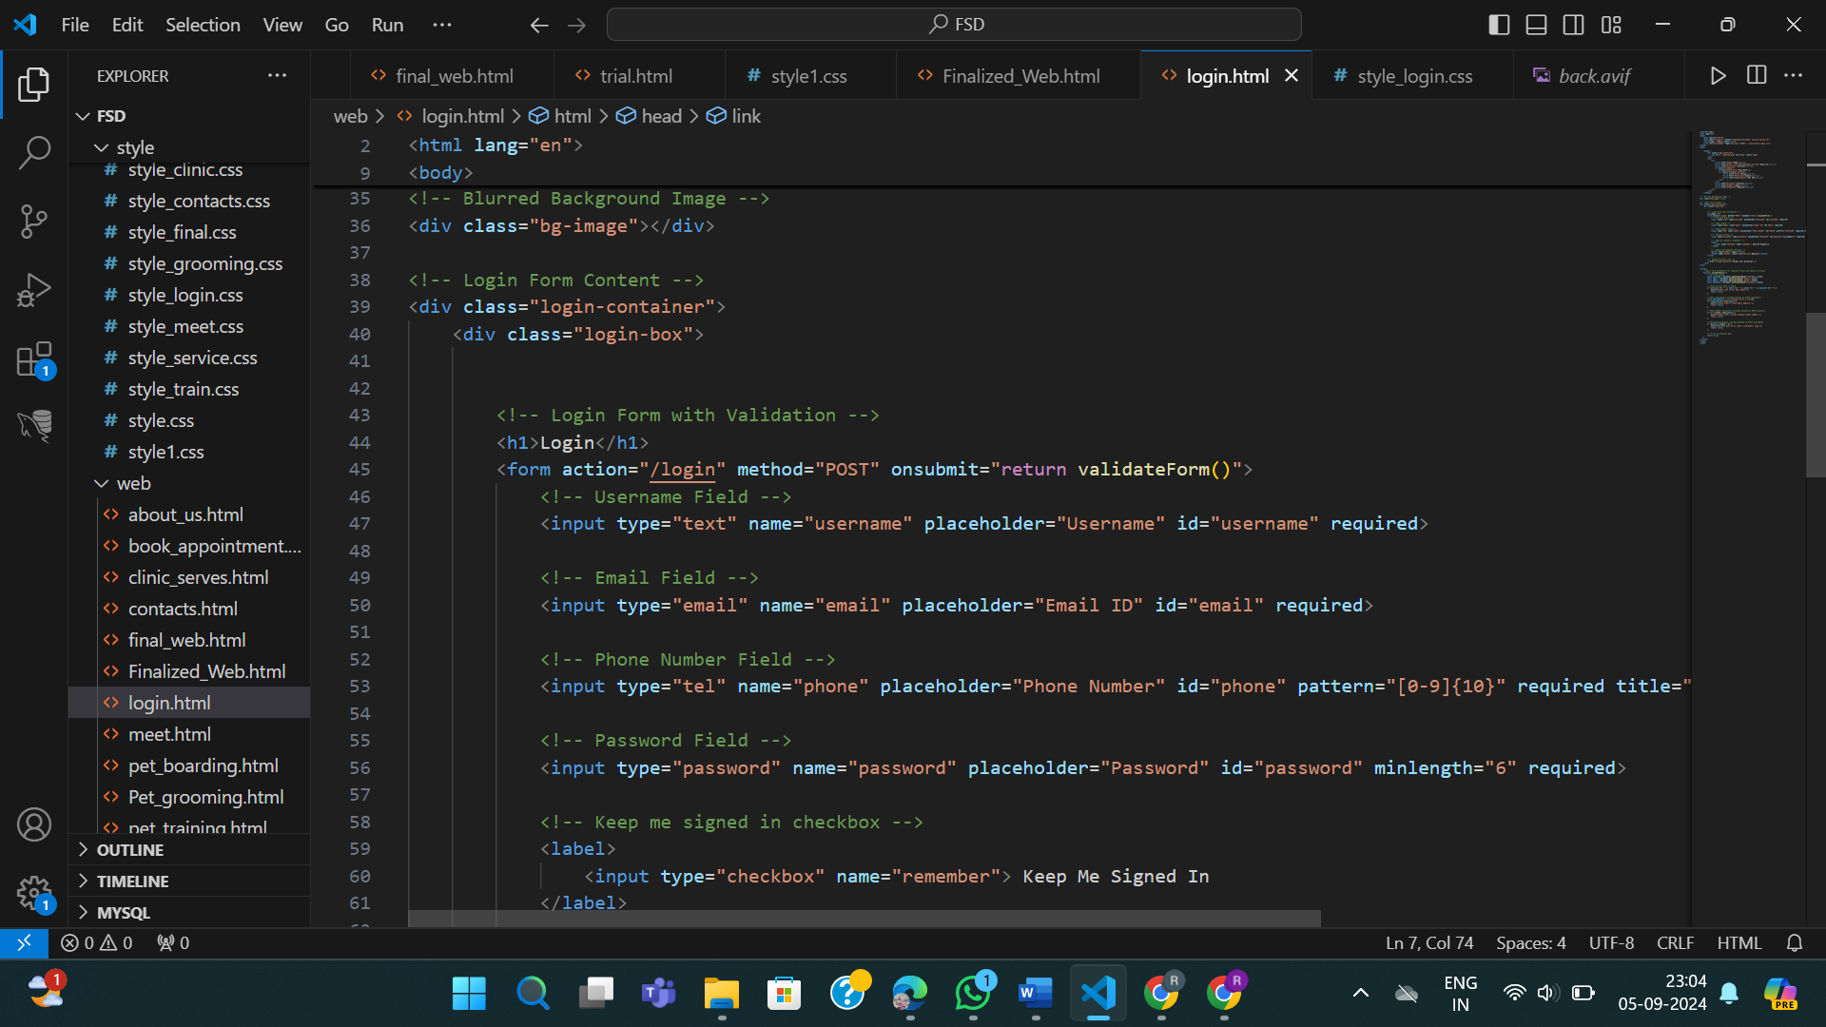

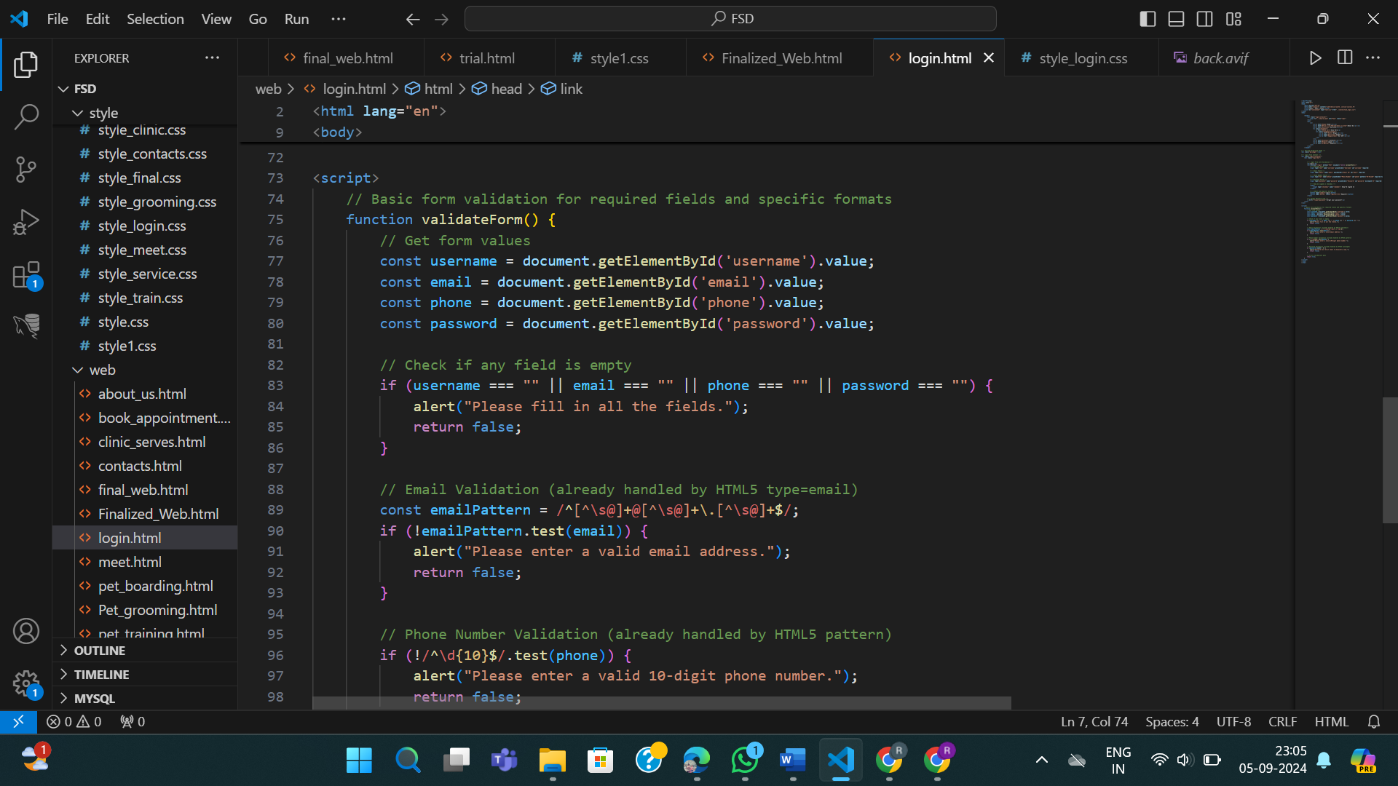

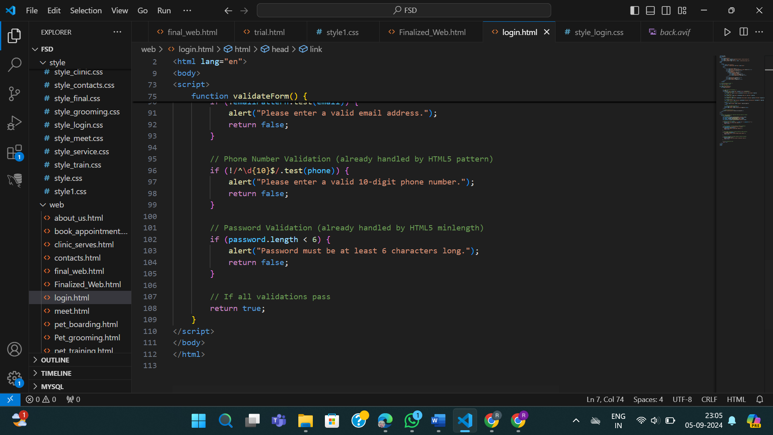

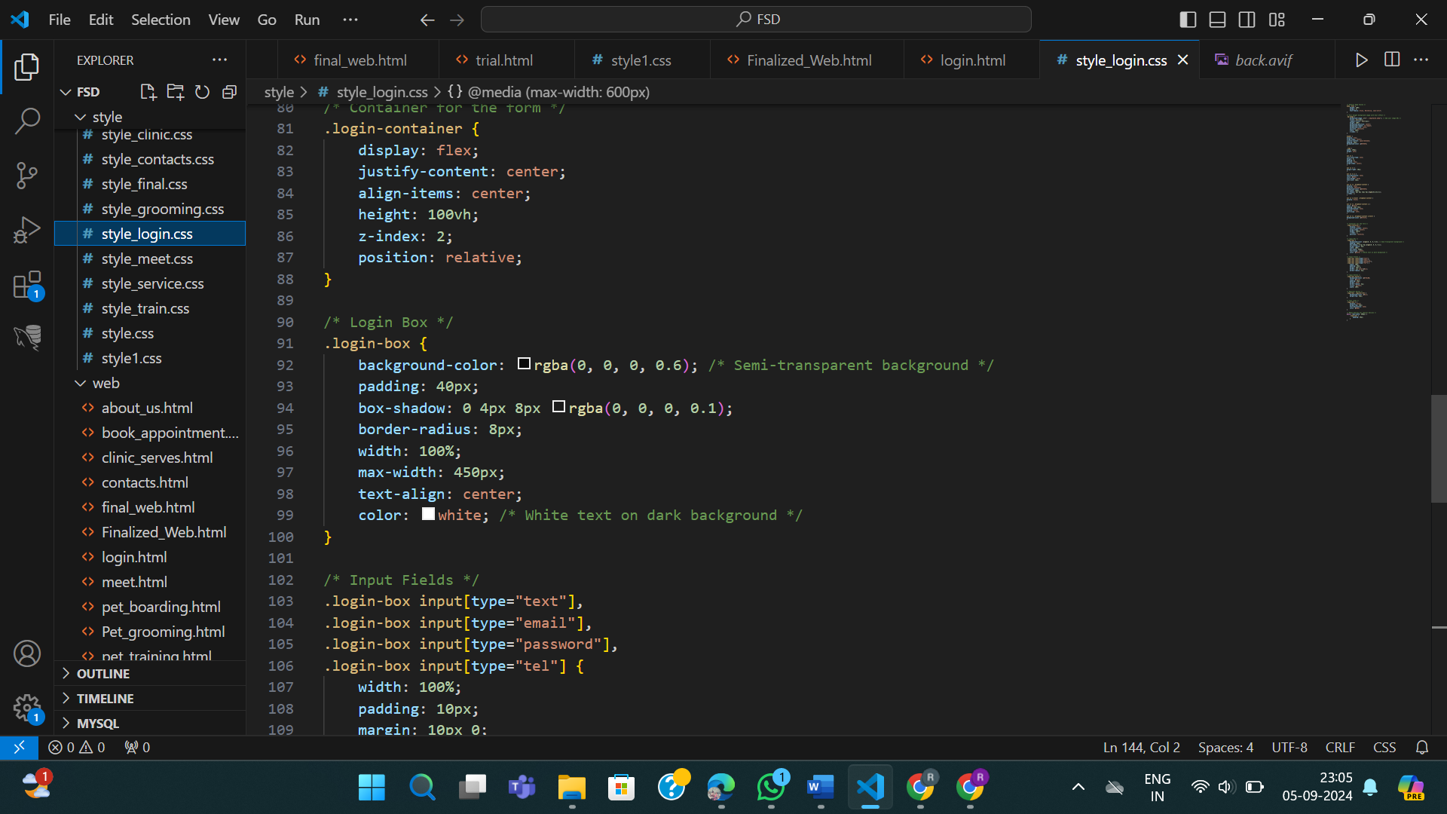

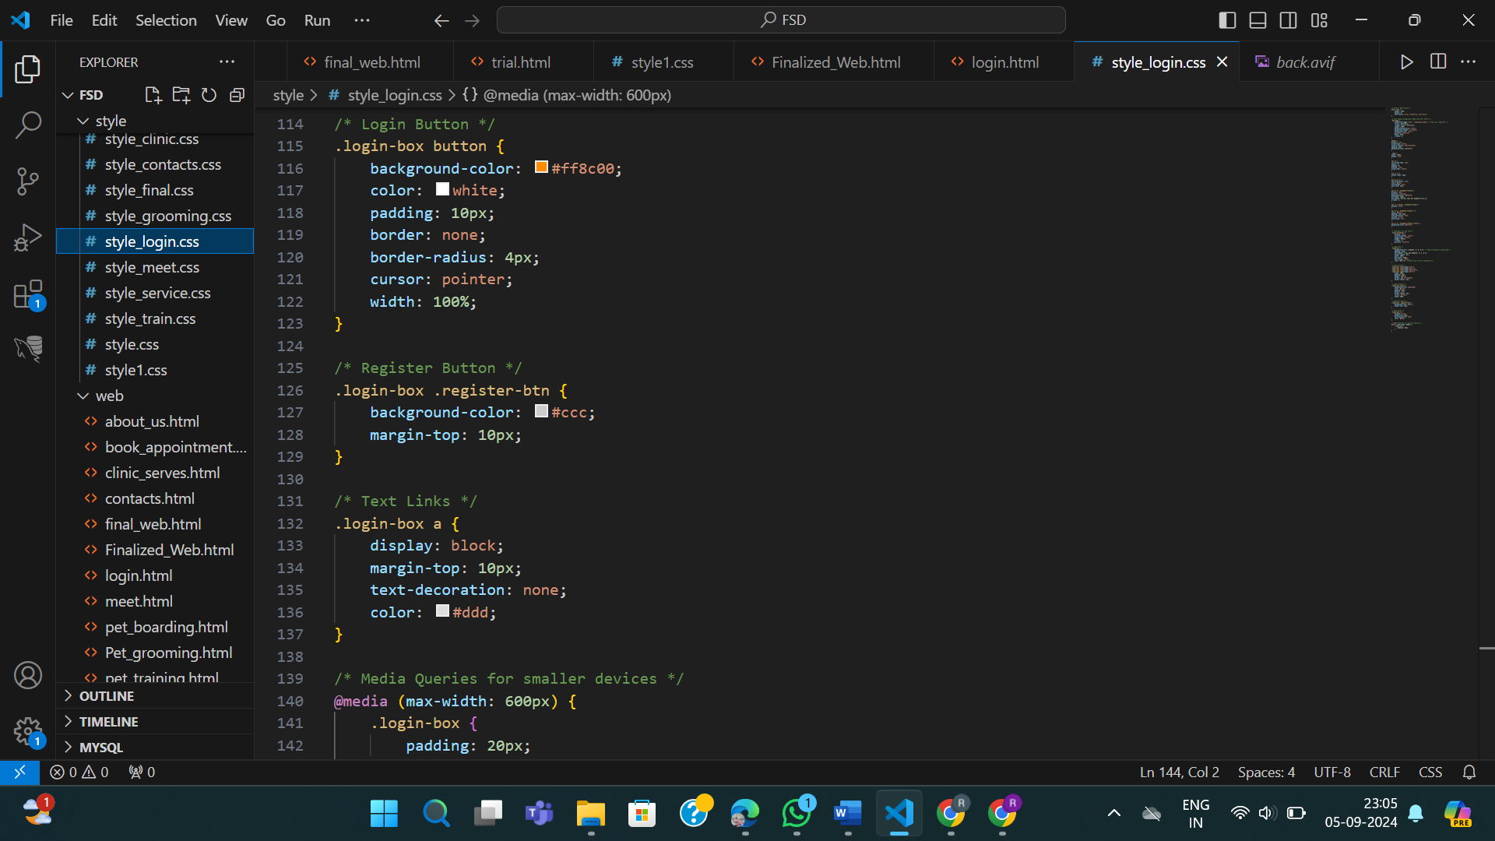

**Lab 2: Domain –**

**Extend your website by adding a navigation menu with at least three main menu**

**items**

1) Adding three new navigation menu items: 'About Us,' 'Products,' and 'Contacts.' The 'About Us' menu will navigate to a page providing information about our story, what is our mission and values and how all are present in our team. Each of the main menu contains submenu which will navigate to its respective page

**Output & Coding:**

**HTML and CSS for about page**

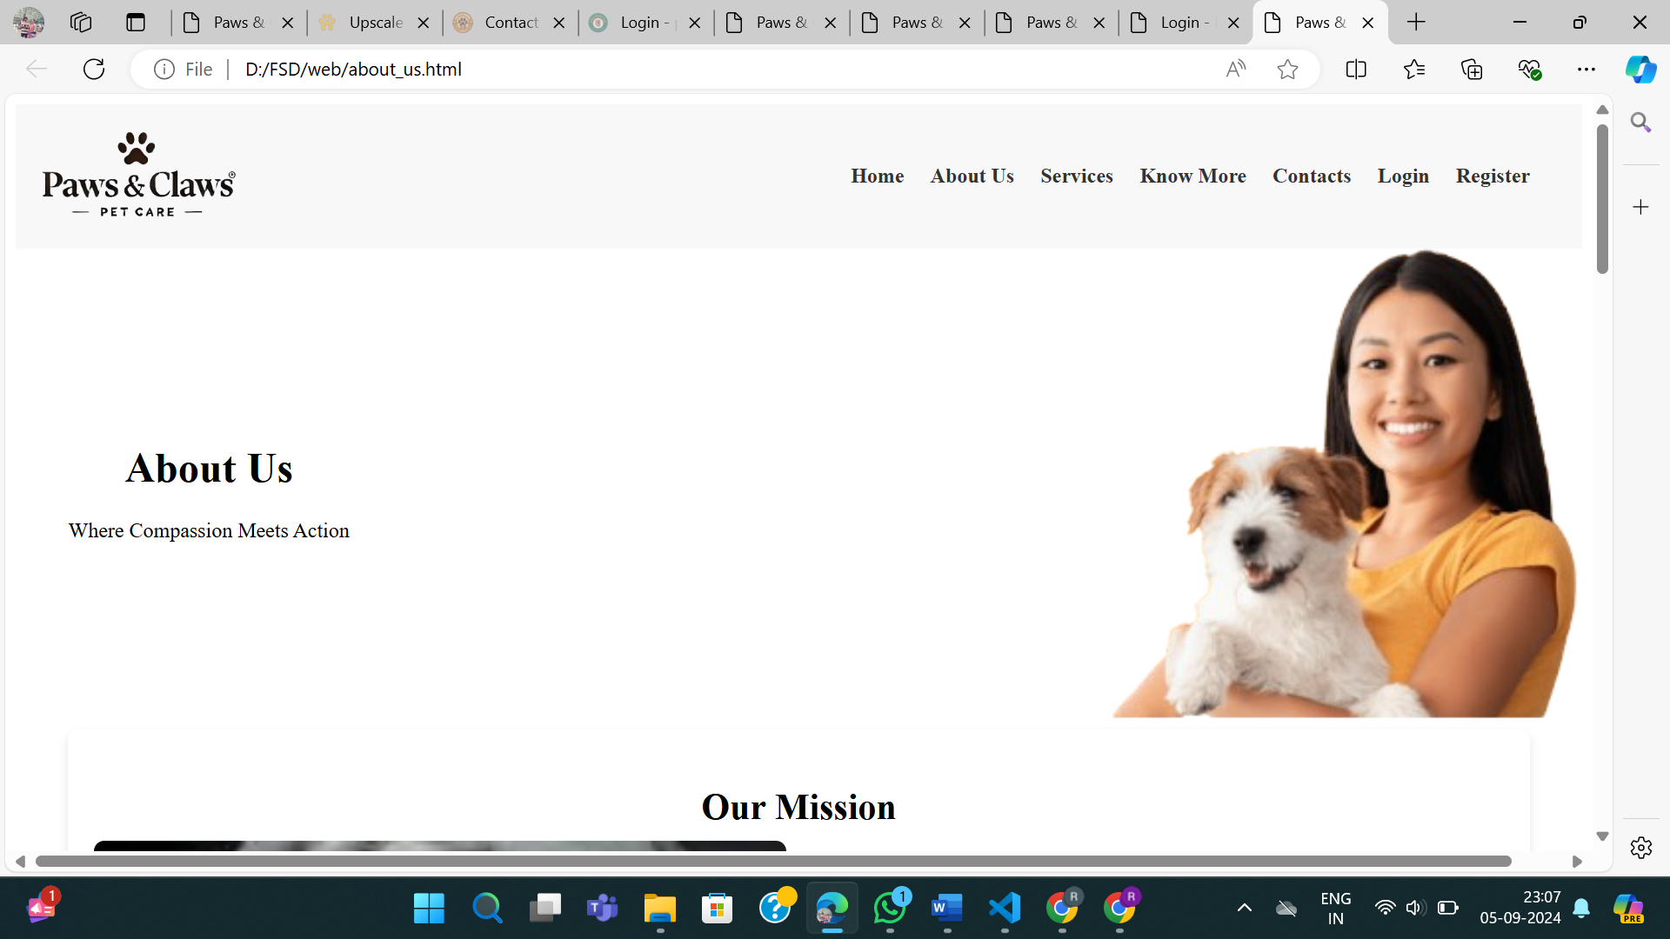

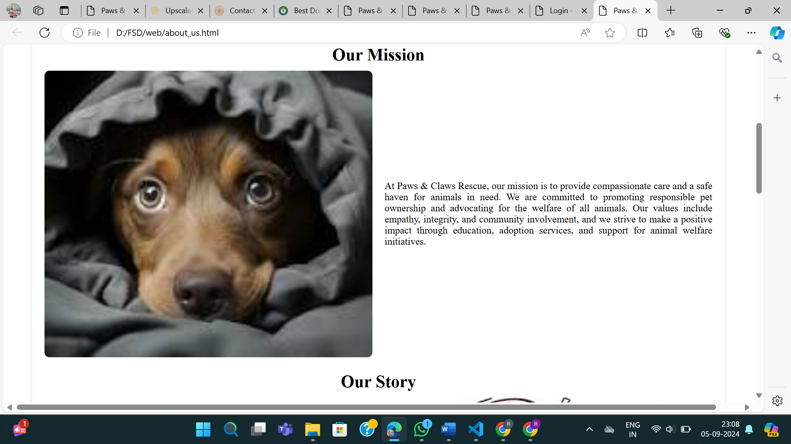

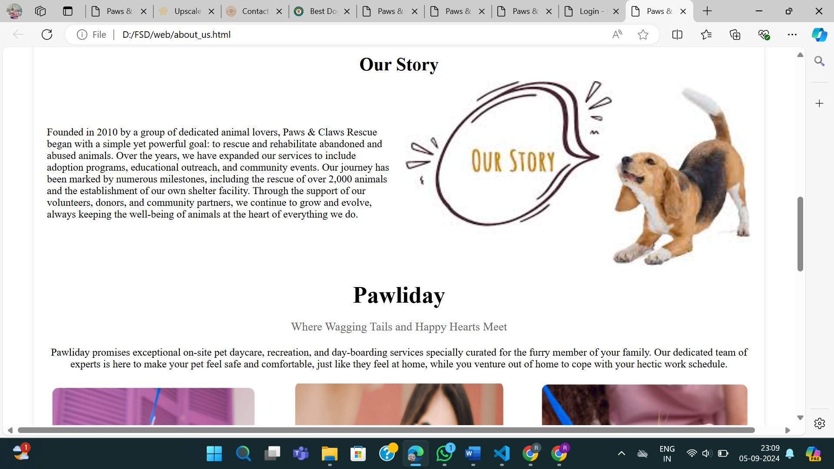

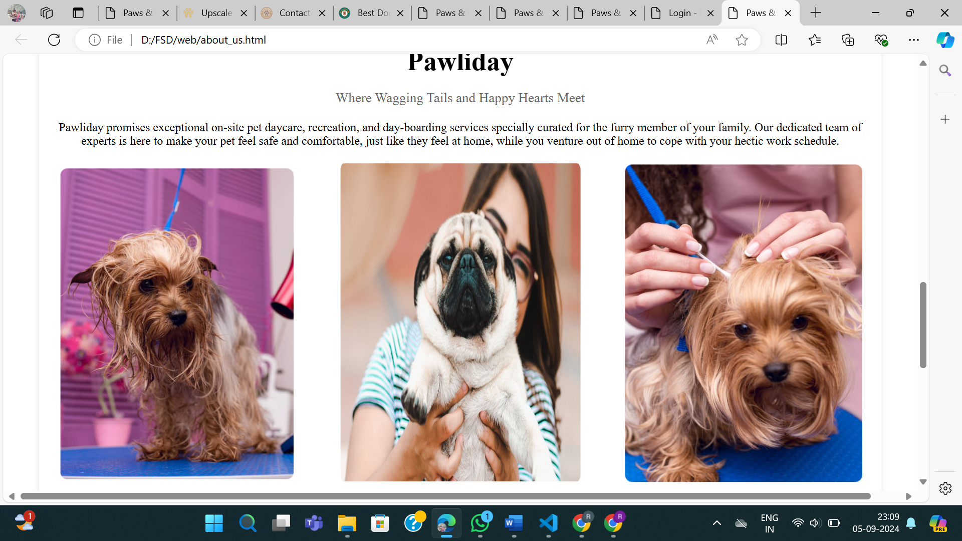

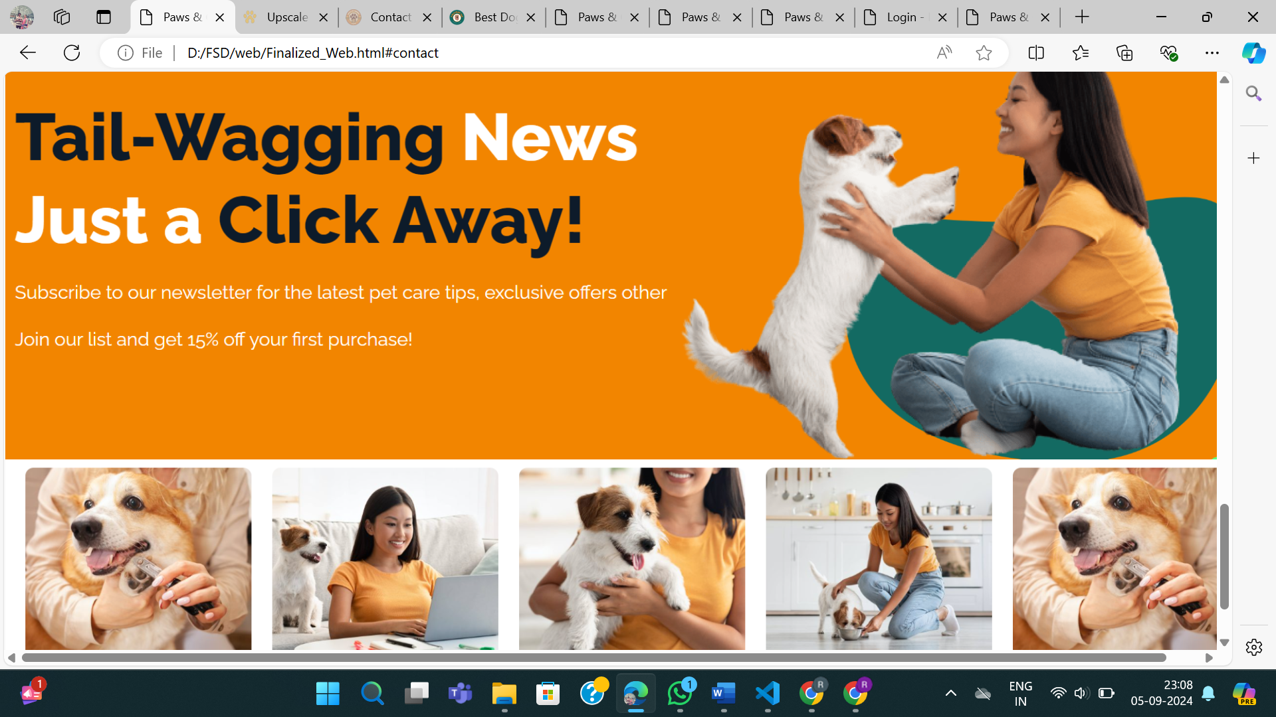

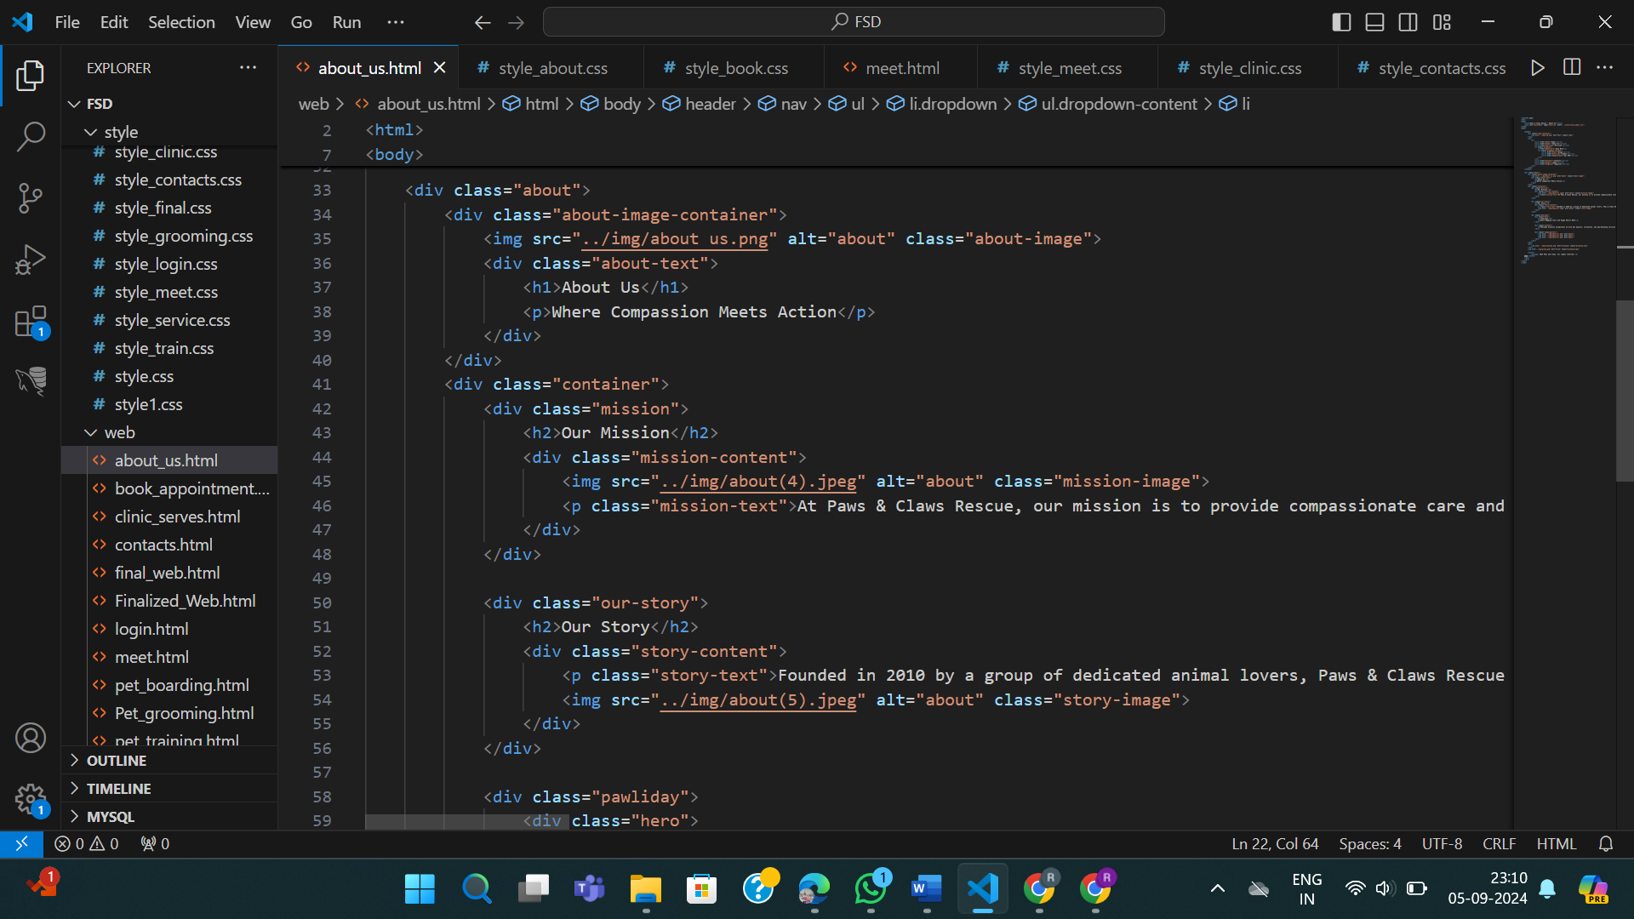

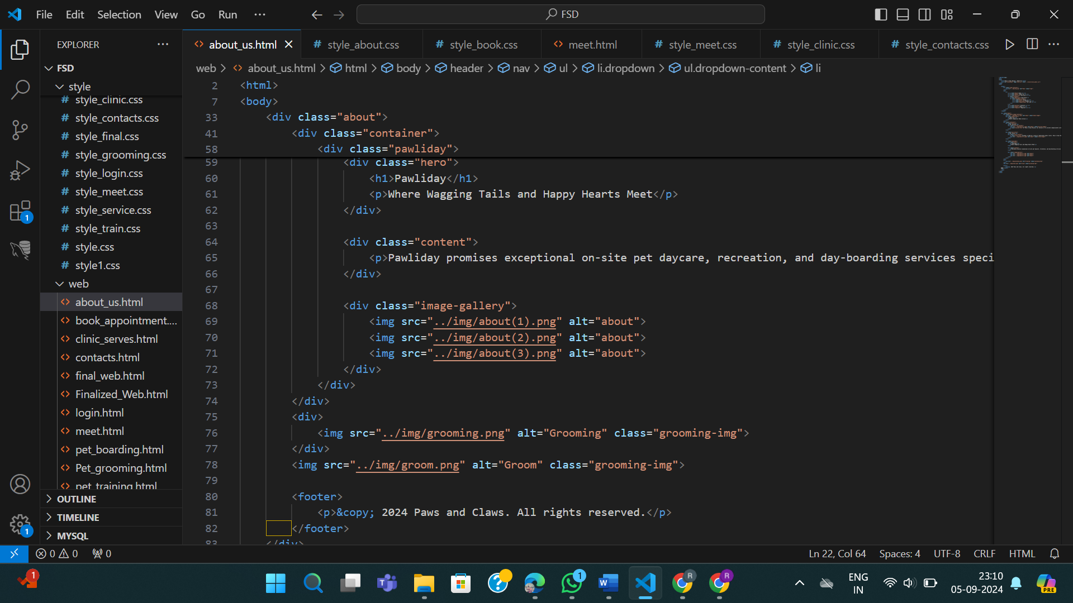

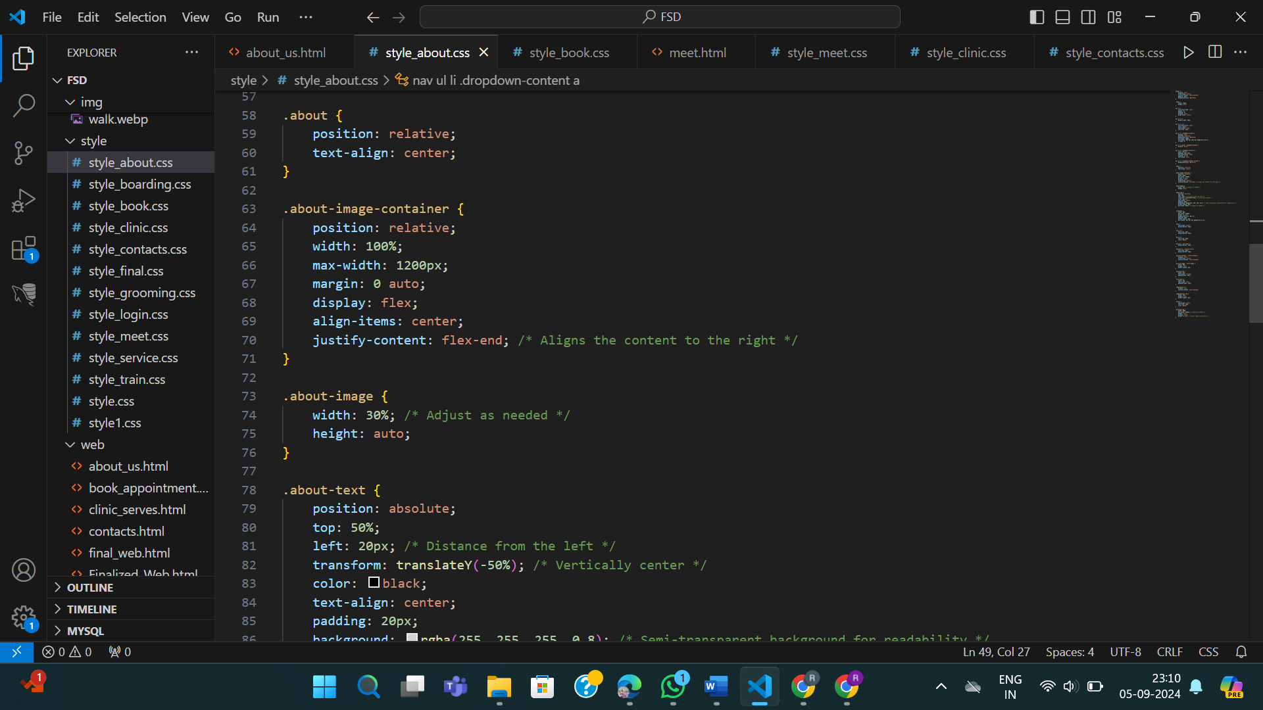

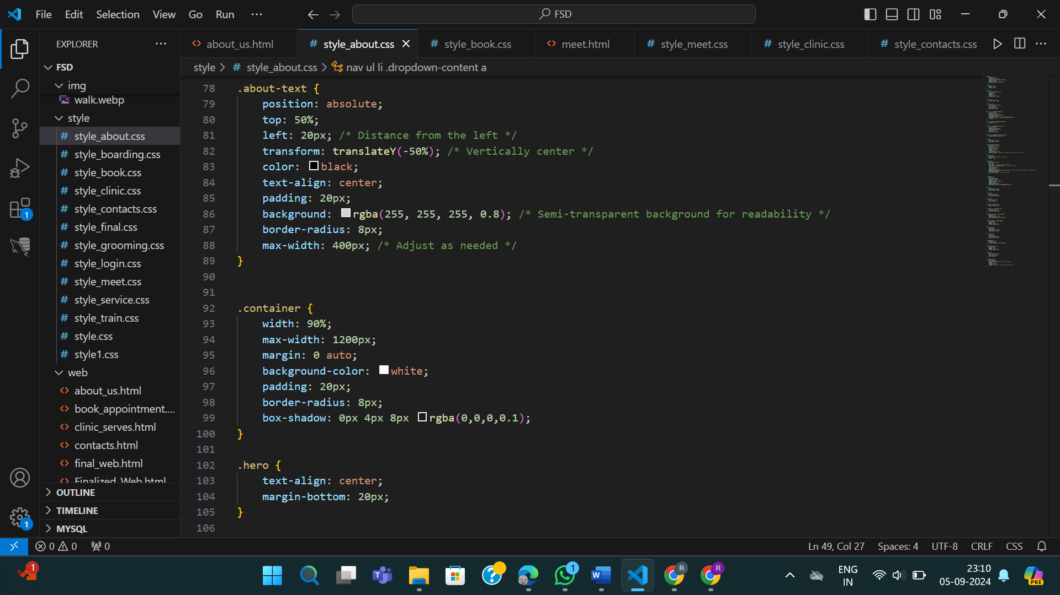

**HTML and CSS for Service page**

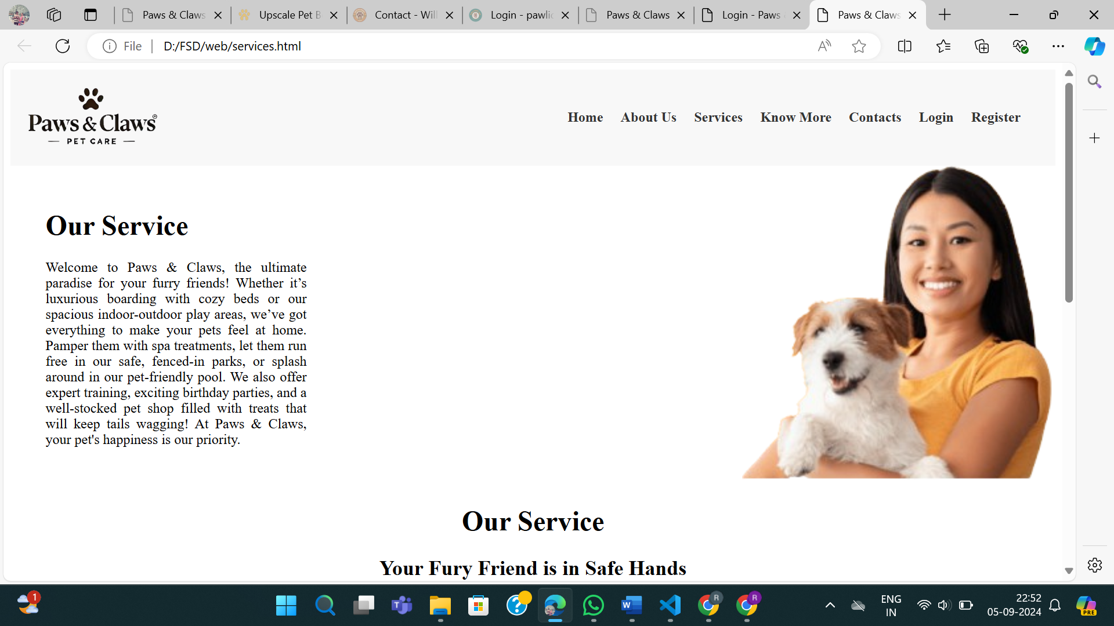

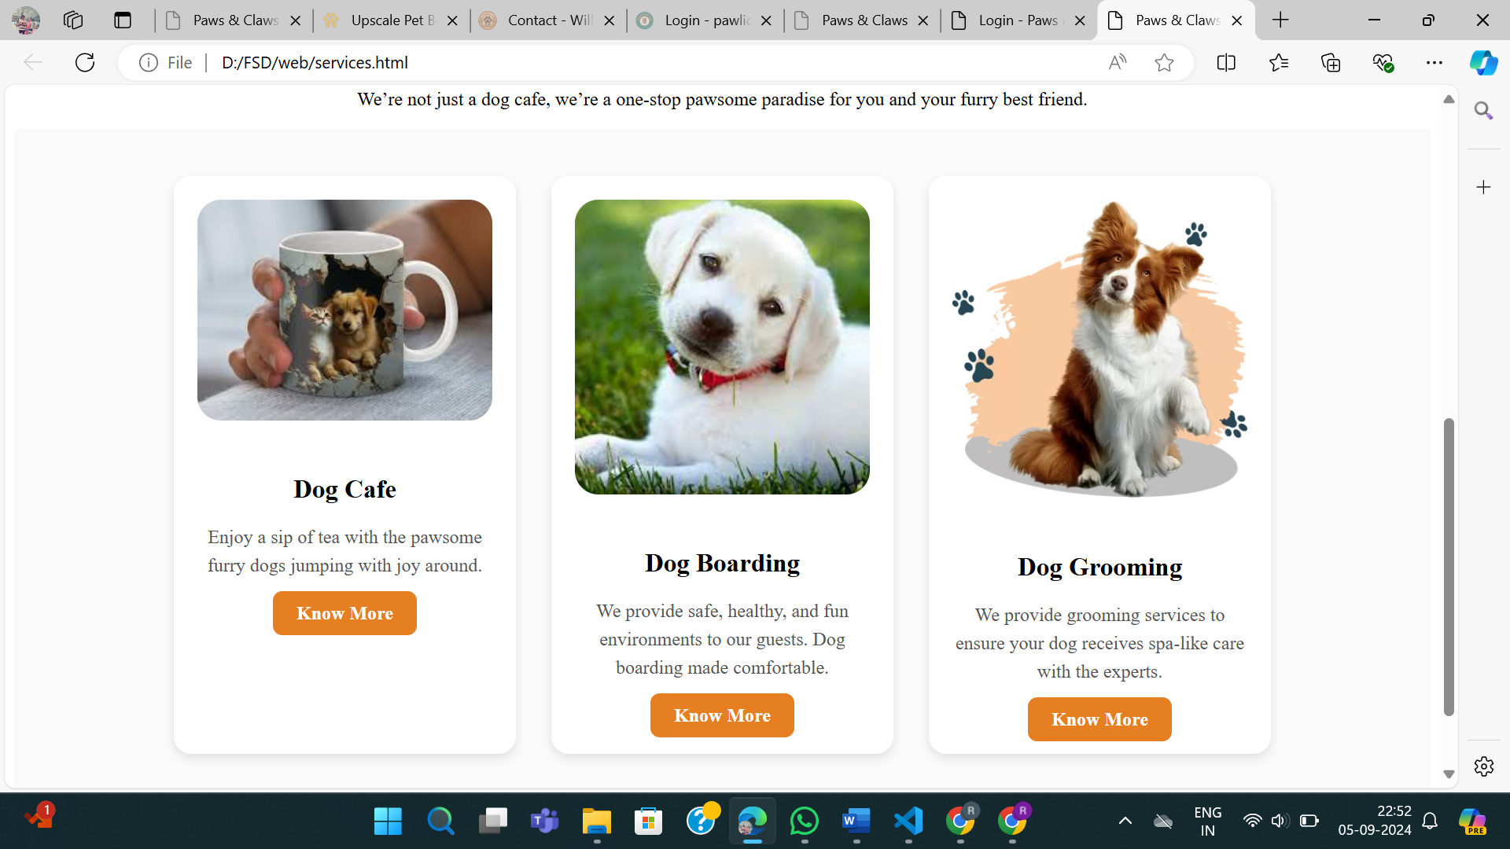

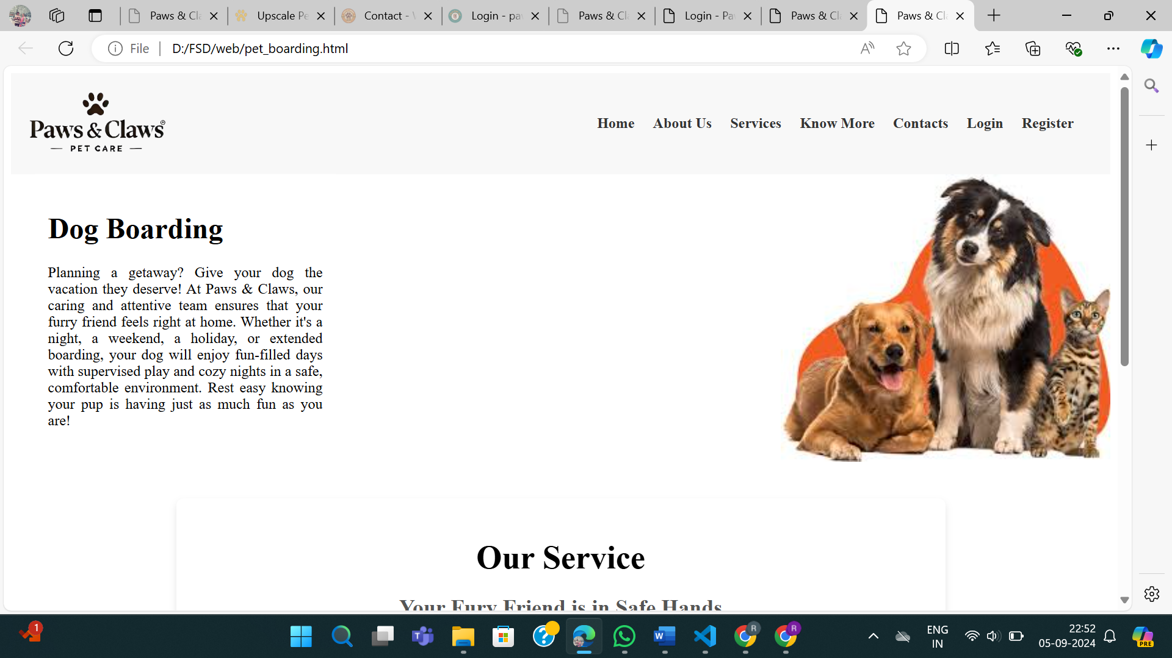

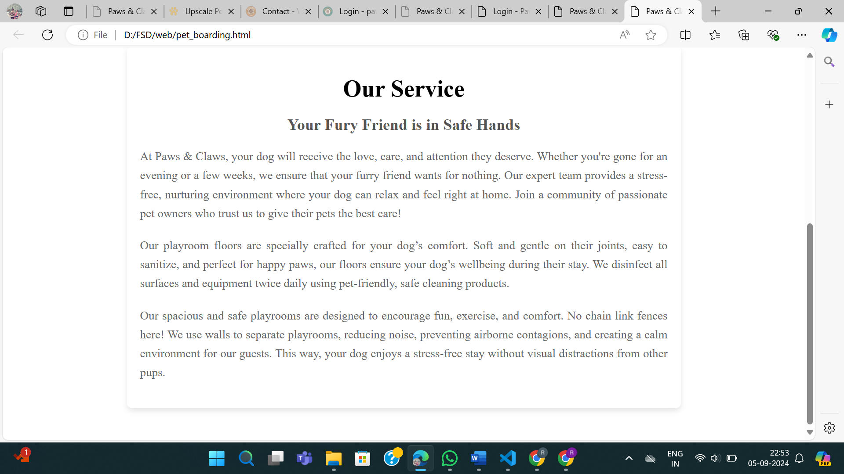

**HTML and CSS for Know More**

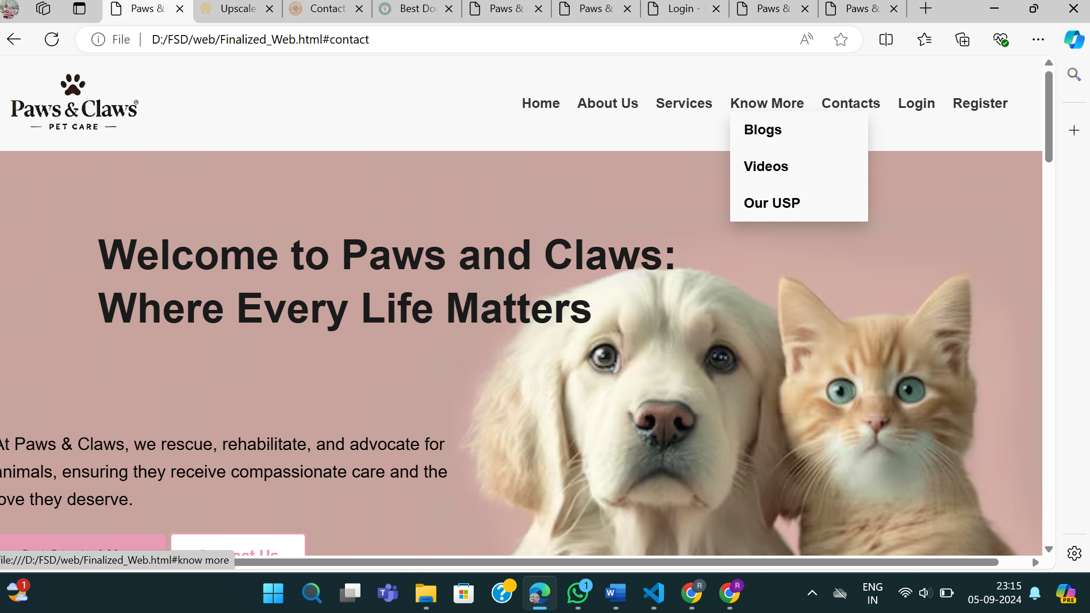

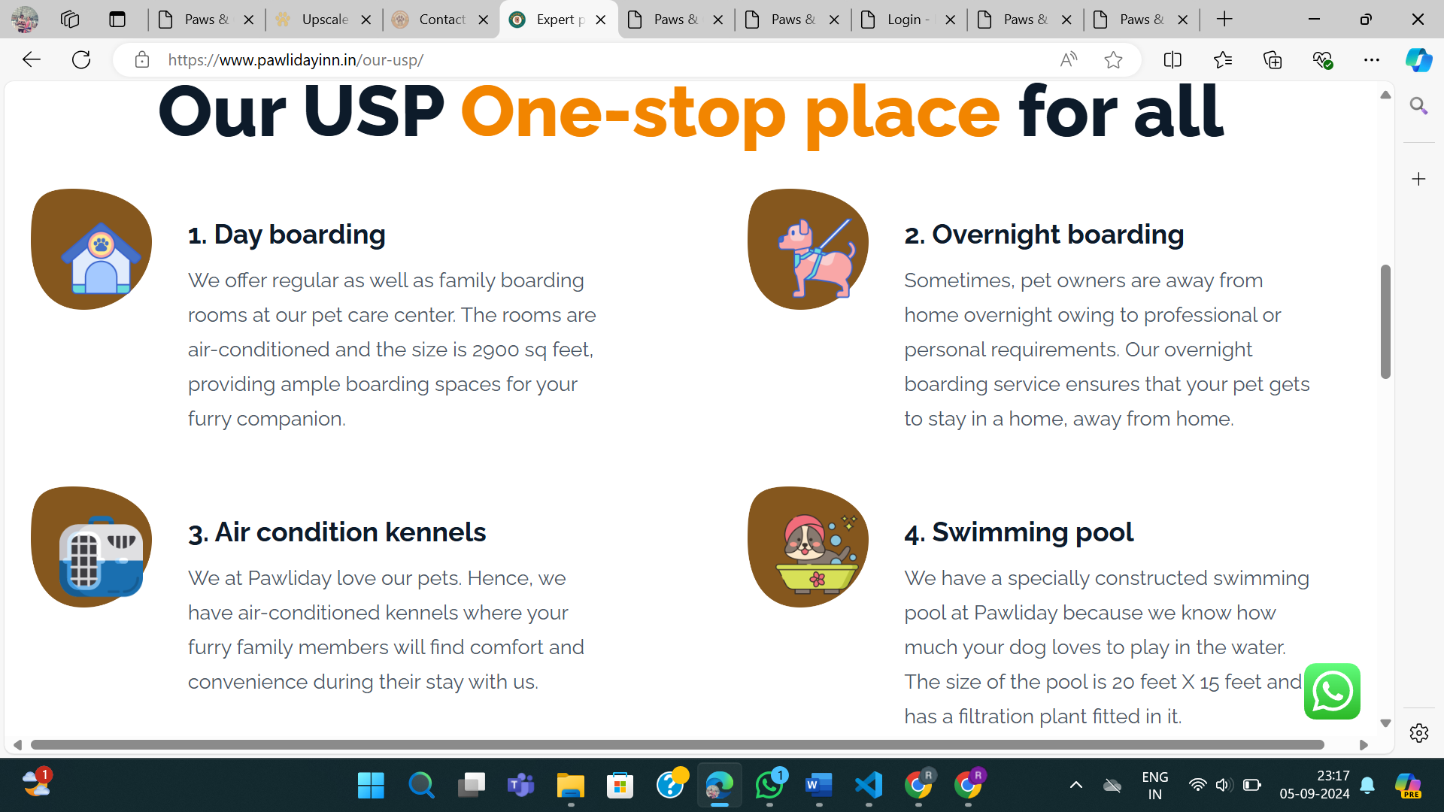

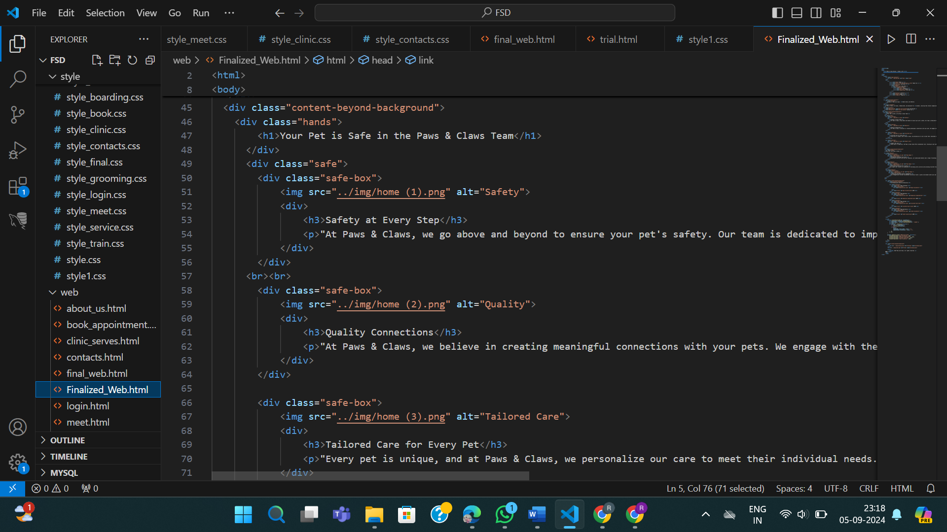

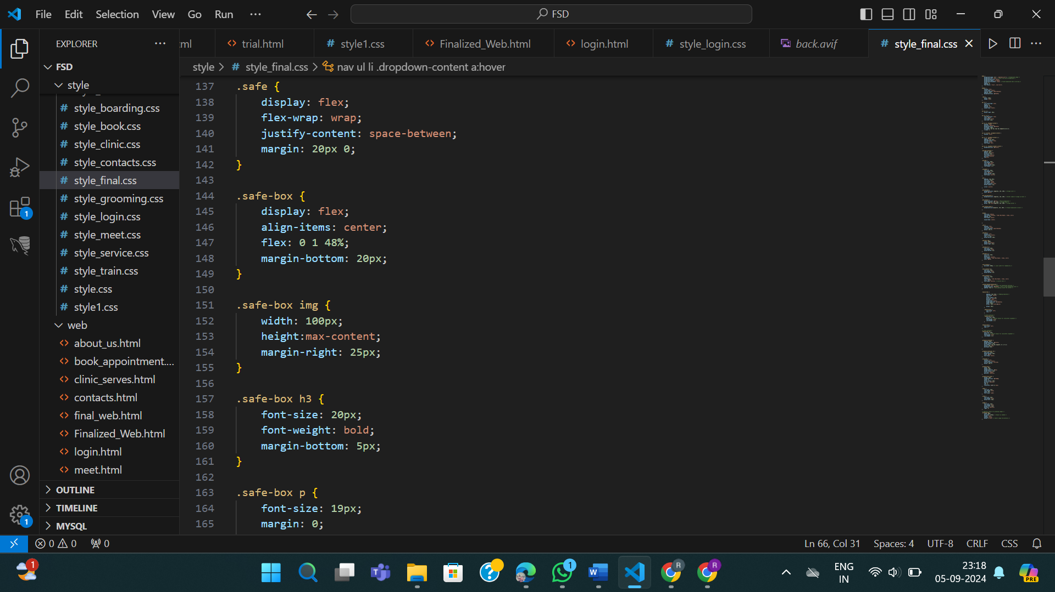

**Lab 3: Domain –**

**Extend you website with new features**

1. Adding new features such as a 'Choose City' option, which will display the city where you live so it displays the nearest warehouse from where vegetables will be sent (functionality is not yet completed). A Feedback Form has been created along with validation.

**Output:**

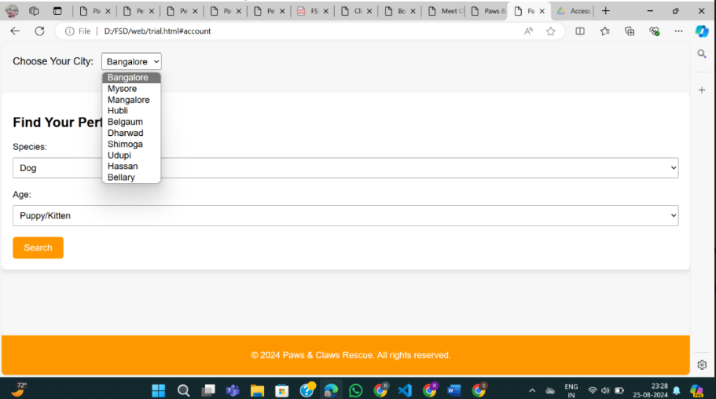

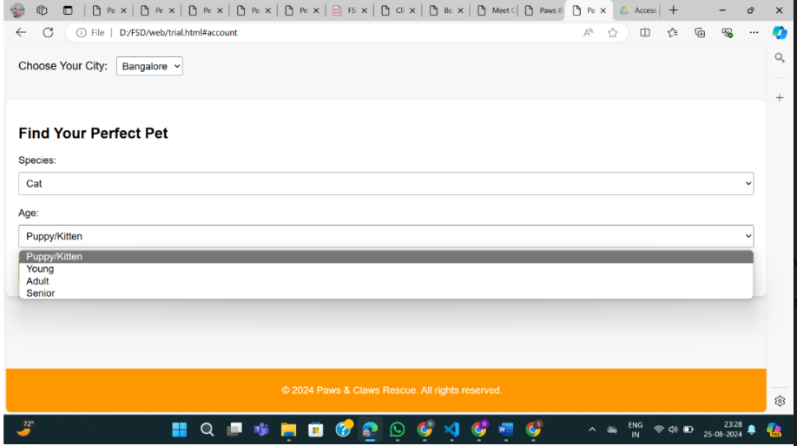

**HTML and CSS for choose city**

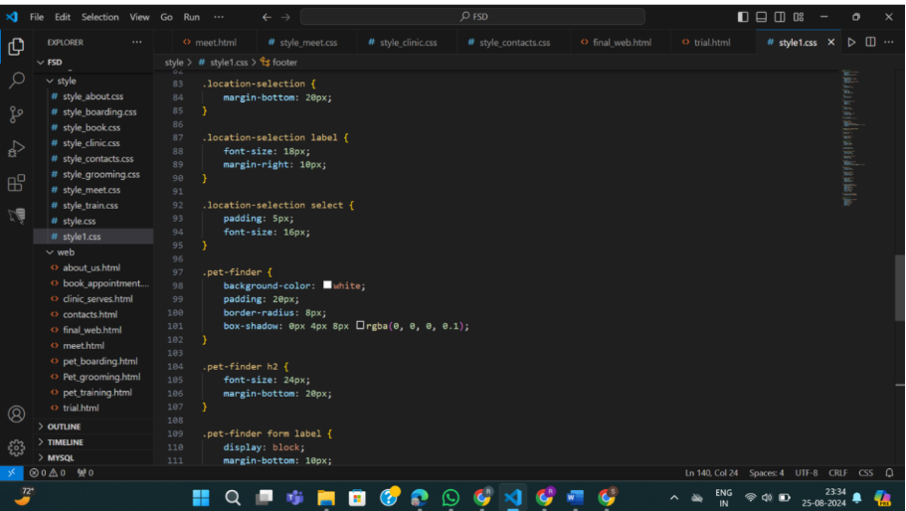

**Conclusion**

The "Farmers Hub" project represents a significant step towards improving the online agricultural marketplace by providing a user-friendly and effective platform for farmers and consumers. The current system, while functional, presents opportunities for enhancement in terms of responsiveness and user experience. The proposed design improvements, including a fixed navigation header, city selection dropdown, and enhanced sign-up process, aim to address these issues and offer a more intuitive and efficient platform. Future developments, including database integration and mobile optimization, will further enhance the functionality and usability of the website, positioning "Farmers Hub" as a leading solution in the agricultural e-commerce space.